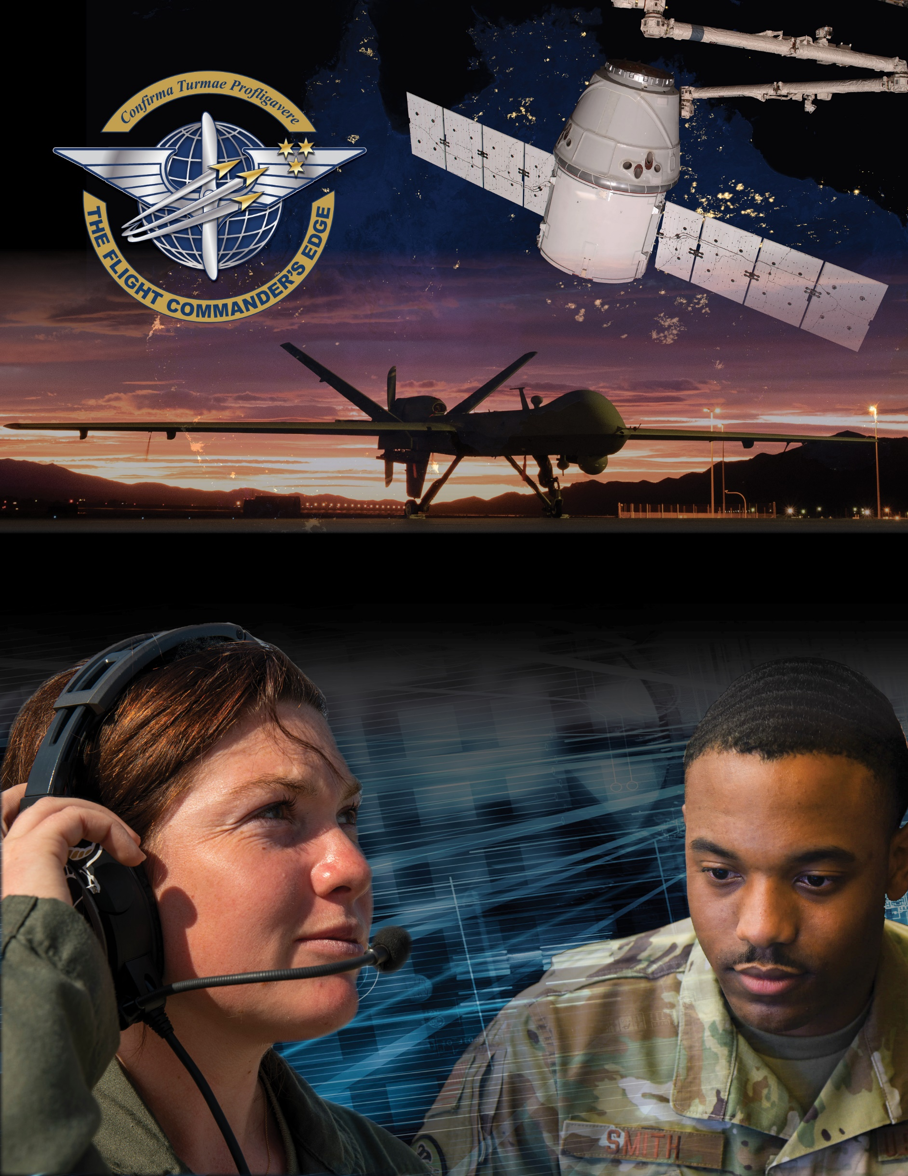

**Lesson Guide**

**Senior Noncommissioned Officer Panel**

***14 April 2025***

**SNCO Panel**

### Purpose

This lesson guide is designed to support the local development of Flight Commander Leadership Course materials. Selected facilitators should use this guide as they prepare presenters and topics. For more information on how lessons are structured, or how to use them in the course, see the ***Course Director’s Handbook*** or online Facilitator Resources.

### Scope

Leaders can learn a lot from the experiences and knowledge of others. This panel of experienced SNCOs have a plethora of familiarity and insight into the task of caring for and developing Airmen, a key responsibility of Flight Commanders.

As a Flight Commander, you are charged with the responsibility of leading and developing others and ensuring mission accomplishment. The flight leadership team bears this responsibility together and must coordinate and cooperate to be effective. This panel of SNCOs has perspective into what tasks are best delegated to flight SNCOs as well as how to cultivate a positive and productive flight culture. They can also provide insight into how the flight leadership team supports the efforts of the squadron leadership team.

### Recommended Objectives

By the end of this lesson, the participant should be able to:

1. Describe the role of SNCOs and how they complement the Flight Commander.
2. Discuss ways to cultivate a flight culture of openness and respect where Airmen enjoy and excel at work.
3. Apply the perspective and experience of squadron SNCOs to your respective situation.

### Recommended POC / Presenter

* No more than three experienced or recently graduated squadron (or equivalent) SNCOs

### Recommended Length:

* 30 minutes (inclusive of questions)

### Recommended Approach

* Informal intro and background of each panel member (AFSC, squadron led and its purpose, etc.) followed by Q & A

**Potential Questions for the Panel to Address**

* What are your primary expectations of your Flight Commanders?
* In your view, what is the most important job of the Flight Commander?
* How can your Flight Commander help you do your job?
* In your experience, what traits/qualities make the best Flight Commanders?
* What error(s) have you seen Flight Commanders make that can undermine a climate of openness and respect?
* And to counter the error(s), what methods have been effective to foster a climate of openness and respect?